NAME: SIGONGAN, IRISH MAE L.

SECTION: IT26-A

IT26 DML Activity: SQL Practice Task

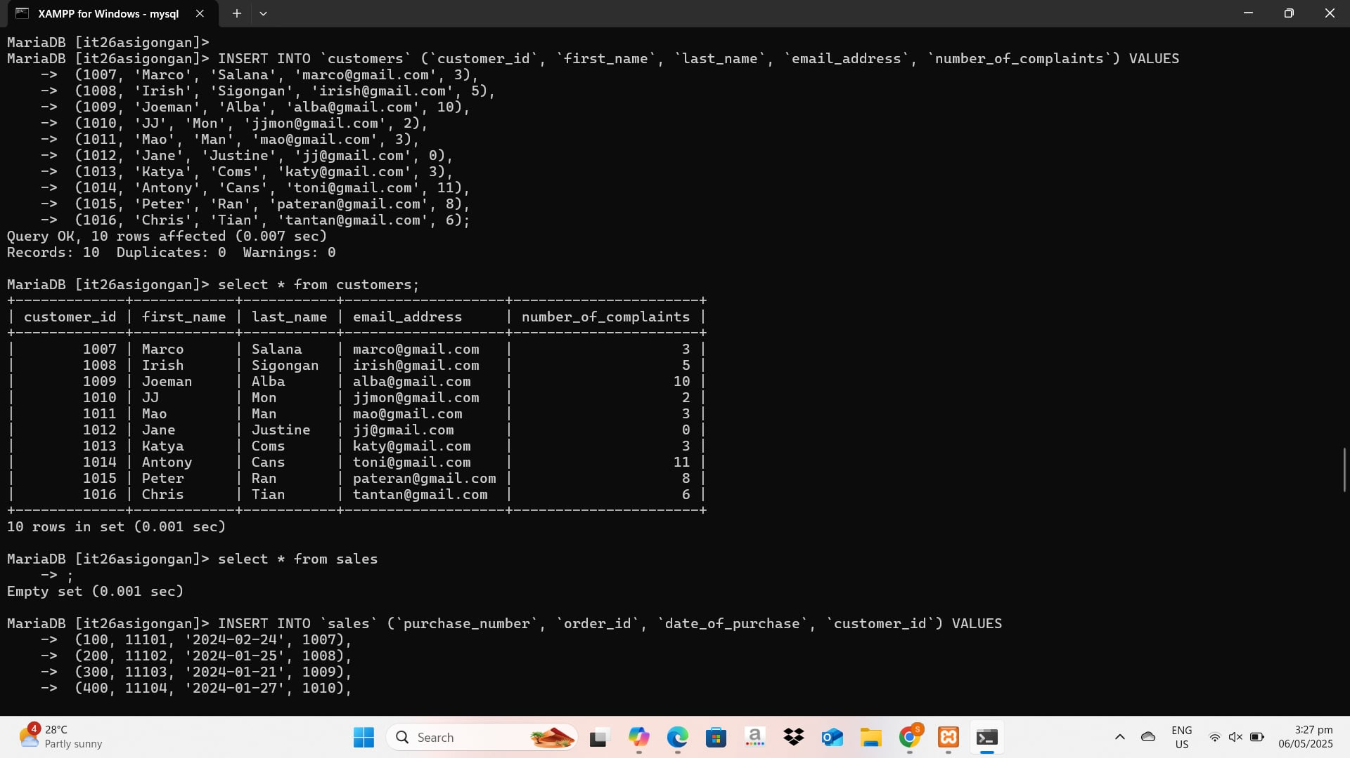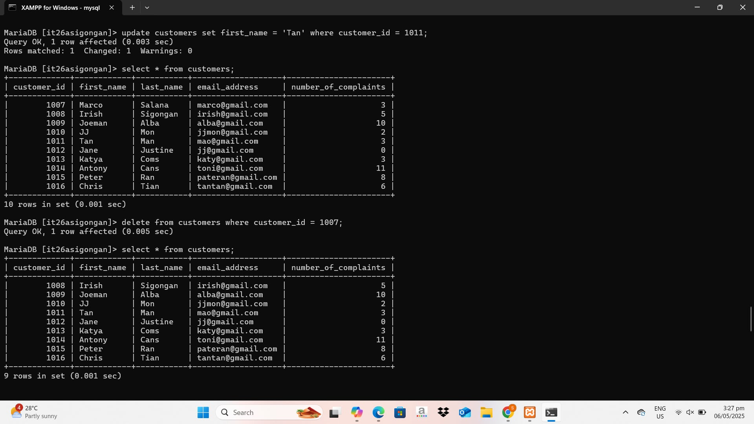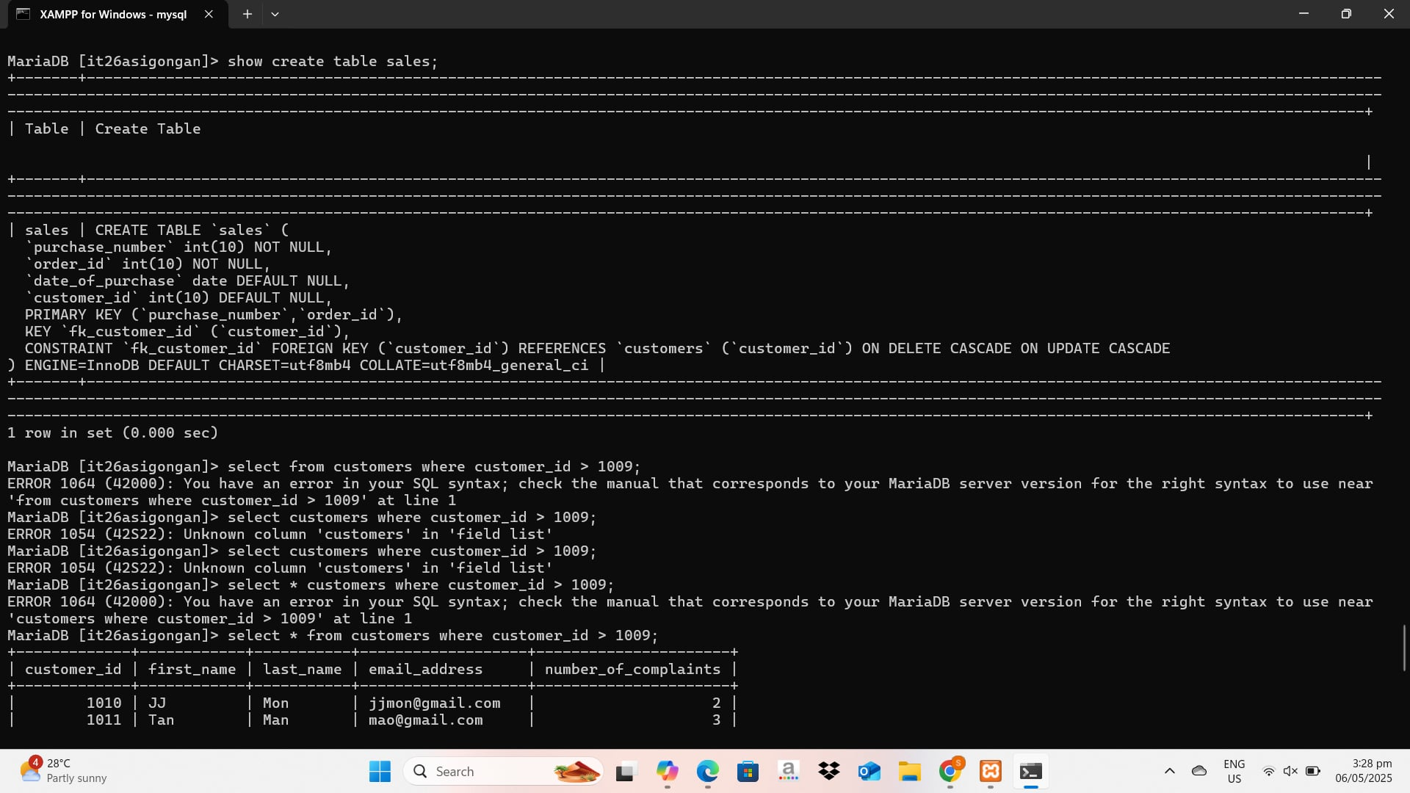

I didn't implement cascading in my SQL work because the necessary cascading actions (such as ON DELETE CASCADE or ON UPDATE CASCADE) were already defined in the existing database schema

